Development of a Computer Program ⎯ COMFAA ⎯ for Calculating Pavement Thickness and Strength

June 4, 2003

Federal Aviation Administration
Airport Technology Research and Development Branch
William J. Hughes Technical Center
Atlantic City International Airport
New Jersey, 08405

TABLE OF CONTENTS

Section Page

1. INTRODUCTION 1

1.1 ACN Computation Mode 1
1.2 Design Pavement Mode 1

2. PROGRAM MODIFICATIONS 1

2.1 Additions to the Aircraft Library 3
2.2 Metrication of COMFAA 3
2.3 Installation of the PCC Design Model from AC 150/5320-6D 4

2.3.1 Installation of Visual Basic Version of H51 4
2.3.2 Extension of H51 Capabilities 5

2.4 Calculation of Slab Thickness 6
2.5 Reliability of COMFAA 10

2.5.1 ACNS Calculated Using the COMFAA, ACNR, and ACNF Programs 10
2.5.2 ACN Numbers for C-17A on Rigid Pavements 12
2.5.3 Slab Thickness Calculated Using COMFAA and AC 150/5320-6D 14

2.6 Analysis of Two Closely Spaced Triple Twin Tandems Using COMFAA 15

3. REFERENCES 18

APPENDIXES

A Characteristics of Aircraft Added to COMFAA

B Comparison of Results Calculated by H51 FORTRAN and Visual Basic Versions

C Rigid and Flexible Pavement ACNs for Aircraft Added to COMFAA

D Wheel Arrangement for Complex Gear Configurations

LIST OF ILLUSTRATIONS

Figure Page

Figure 1. Graphical User Interface for COMFAA Displaying Data in Metric Units 4
Figure 2. Calculation of Slab Edge Stress for Any Wheel Location Using the Concept of Superposition 5
Figure 3. Search Paths for Maximum Stress Location 6
Figure 4. Algorithm for Calculating Slab Thickness 8
Figure 5. COMFAA Graphic Interface with Design Thickness Result 9
Figure 6. COMFAA Results for C-17A Aircraft 13
Figure 7. COMFAA Results for Three Wheels out of Six on C-17A Aircraft 14
Figure 8. Two Closely Spaced Triple Twin Tandems 16
Figure 9. Contribution of Individual Wheels to Slab Edge Stress at Location "A" for Two Triple Twin Tandems (Slab Thickness = 14.90 inches (37.85 cm), k = 100 pci (27.1 kg/cm³)) 16
Figure 10. Contribution of Individual Wheels to Slab Edge Stress at Location "A" for Two Triple Twin Tandems (Slab Thickness = 12.62 inches, k = 200 pci) 17
Figure 11. 3-D Surface of Edge Stress Depending on Wheel Position at Coordinates x and y (Slab Thickness = 12.62 inches, k = 200 pci) 17
Figure 12. Surface Chart, Viewed from Above, of Edge Stress Depending on Wheel Position at Coordinates x and y (Slab Thickness = 12.62 inches, k = 200 pci) 18

LIST OF TABLES

Table Page

1. Aircraft Added to COMFAA Library 3
2. ACNs for IL75T Aircraft 11
3. ACNs for IL75T Aircraft 11
4. ACNs for Selected Aircraft on Rigid Pavements 12
5. ACNs for Selected Aircraft on Flexible Pavements 12
6. ACNs for C-17A Aircraft on Rigid Pavements 13
7. ACNs for Three out of Six Wheels for C-17A Aircraft on Rigid Pavements 13
8. Input Data for Thickness Designs 14
9. Results of Thickness Designs 15
10. Comparison of Design Thicknesses Obtained by AC 150/5320-6C and COMFAA 15

ACRONYMS AND ABBREVIATIONS

AC Advisory Circular
ACN Aircraft Classification Number
ACNF ICAO Program for Calculating ACNs for Flexible Pavements
ACNR ICAO Program for Calculating ACNs for Rigid Pavements
CBR California Bearing Ratio
cm Centimeter
FAA Federal Aviation Administration
GW Gross Weight of the Aircraft
HTML Hyper Text Markup Language
ICAO International Civil Aviation Organization
k Modulus of Subgrade Reaction
kg Kilogram
kp Kilopound
LEDFAA Layered Elastic Design - FAA
MN/m³ Meganewton per Cubic Meter
Mpa Megapascal
PCA Portland Cement Association
PCC Portland Cement Concrete
pci Pounds per Cubic Inch
psi Pounds per Square Inch
Rc Concrete Flexural Strength for PCC Layer
RTBIS Function Using Bisection Method for Finding Root of the Equation

INTRODUCTION
COMFAA is a general-purpose program that operates in two computational modes: Aircraft Classification Number (ACN) Computation Mode and Design Pavement Mode. This program is based on modifications made to the FAA’s ACNComp computer program dated August 1997.

ACN Computation Mode
In ACN Computation Mode, COMFAA performs the following functions:

- Calculates the ACN for aircraft on flexible pavements.
- Calculates the ACN number for aircraft on rigid pavements.
- Calculates flexible pavement thickness based on the California Bearing Ratio (CBR) method in Advisory Circular (AC) 150/5320-6D for default values of CBR (15, 10, 6, and 3).
- Calculates rigid pavement slab thickness based on the Portland Cement Association (PCA) method for default values of k (552.6, 294.7, 147.4, and 73.7 lb/in³ – 150.0, 80.0, 40.0, and 20.0 kg/cm³).

Design Pavement Mode
In Design Pavement Mode, COMFAA:

- Calculates flexible pavement thickness based on the CBR method in AC 150/5320-6D for the CBR value specified by the user.
- Calculates rigid pavement slab thickness based on Federal Aviation Administration (FAA) AC 150/5320-6D for the k value specified by the user.
ACNs are calculated according to Annex 14 of the International Civil Aviation Organization (ICAO) Airport Pavement Design Manual. The computer programs listed in Appendix 4 of the ICAO manual have been implemented in COMFAA and these implementations are believed to accurately reproduce the ACNs computed by the ICAO programs. However, inconsistencies may exist between the ICAO listings and the COMFAA implementations. COMFAA is not a substitute for the ICAO programs.

PROGRAM MODIFICATIONS
The following modifications were made to ACNComp, August 1997 version, to develop the COMFAA program:

- ACNCOMP was checked and modified so that the characteristics for the aircraft in the internal library and listed in the current edition of the ICAO publication, "Aerodrome Design Manual: Part 3 – Pavements" [a.], are in agreement.
- Thirty aircraft were added to the aircraft library. COMFAA now contains all of the aircraft in the current edition of the ICAO Design Manual [a.].
- The frame labeled "Computational Mode", with two option buttons, was added to the Graphic User Interface. The user now has the option to select either the ACN Computation mode or the Pavement Design mode.
- The Portland Cement Concrete (PCC) design model from FAA AC 150/5320-6D [b.] was installed. The thickness design in this version is now based on edge stress, rather than interior stress.
- The user cannot change the aircraft tire pressure in the ACN Computation Mode or the Tire Contact Area in the Pavement Design Mode unless the aircraft is in the external library.
- When the user saves an aircraft in the external library, an additional parameter, Tire Contact Area, is saved in the external file, ACNacrft.Ext.
- H51 [c.] capabilities were extended to include slab stress calculations for gear configurations not included in the H51 program.
- Metrication was added.
- The Conventional Windows Help File was updated and converted into an HTML help file format. The updates to the Help File text include the following:
      - An explanation that the slab thickness is calculated from interior stress if the user does not specify a k value and from edge stress if the user specifies a k value when using the "Change Pavement Structure" feature.
      - Information was added regarding the Rc (concrete flexural strength for PCC layer) field in the output grid for the topic "Change Pavement Structure."
- The readme.txt file was modified.
- It was discovered that a cutoff value larger than the 3* (Radius of Relative Stiffness) standard by ICAO is required for the C-17A to avoid unreasonable results for ACNs.
- The reliability of the calculations affected by the modifications was evaluated and verified to be accurate.
- Dimensions for the C-17A gear configuration were modified according to the report "C-17 Pavement Design and Evaluation Criteria."
Details of the work performed are given in the following sections.

Additions to the Aircraft Library
A comparison of the aircraft contained in the ICAO Design Manual and COMFAA was conducted. Table 1 lists the 30 aircraft that were added to the existing list of 60 aircraft in the COMFAA internal library as a result of the comparison. Appendix A contains the aircraft characteristics.

Table 1. Aircraft Added to COMFAA Library
Aircraft Group | Number | Added Aircraft Type
Airbus | 1 | A-310-200
Airbus | 2 | A-320 Dual Tandem
Boeing | 3 | B-720
McDonnell Douglas | 4 | DC-3
McDonnell Douglas | 5 | DC-4
McDonnell Douglas | 6 | DC-8-43
McDonnell Douglas | 7 | DC-10-15
McDonnell Douglas | 8 | MD-87
Other Commercial | 9 | BAC 1-11 Series 400
Other Commercial | 10 | BAC 1-11 Series 475
Other Commercial | 11 | Caravelle 10
Other Commercial | 12 | Caravelle 12
Other Commercial | 13 | Canadair CL-44
Other Commercial | 14 | CV 880 M
Other Commercial | 15 | CV 990
Other Commercial | 16 | Dash 7
Other Commercial | 17 | F27 Friendship Mk500
Other Commercial | 18 | F28 Fellowship Mk1000LPT
Other Commercial | 19 | F28 Fellowship MK1000HTP
Other Commercial | 20 | Fokker 50 HTP
Other Commercial | 21 | HS125
Other Commercial | 22 | HS748
Other Commercial | 23 | IL62
Other Commercial | 24 | IL76T
Other Commercial | 25 | IL86
Other Commercial | 26 | L-100-20
Other Commercial | 27 | Trident 1E
Other Commercial | 28 | TU134A
Other Commercial | 29 | TU154B
Other Commercial | 30 | VC10-1150

Metrication of COMFAA
Metrication was added to COMFAA similar to the metrication in LEDFAA. It does not affect the calculations conducted by COMFAA, which are in English units, as was done before metrication was added to the program. Metrication only affects values displayed by the graphical interface. For example, calculations with the variable "TirePressure" always use the unit, pounds per square inch (psi). The value to be displayed for the tire pressure is the value of "TirePressure" (in psi) multiplied by a conversion coefficient that is assigned dependent on the condition of the checkbox for metric values located in the lower left corner of the main window, as shown in figure 1. The user can enter the value of tire pressure in either English or Metric units.

NOTE: For "TirePressure," the value of the conversion coefficient is 1 when tire pressure is entered in English units or 6.894757 when tire pressure is entered in Metric units.

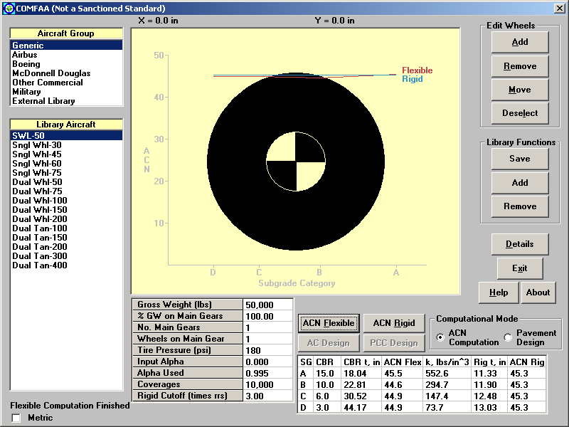
Figure 1. Graphical User Interface for COMFAA Displaying Data in Metric Units

Installation of the PCC Design Model from AC 150/5320-6D
The following modifications were made to enable COMFAA to calculate single-aircraft rigid pavement thickness design according to the Westergaard-based procedure specified in FAA AC 150/5320-6D [b.].

Installation of Visual Basic Version of H51
H51 [c.] is a FORTRAN computer program that calculates slab edge stresses resulting from loads applied by aircraft landing gears. It is based on the theory of a semi-infinite plate on an elastic foundation [c.]. The H51 FORTRAN program was converted to Visual Basic, and the new program (TestH51) was thoroughly debugged to ensure that the results were the same as those from H51 within numerical roundoff. (The comparison of the results from both programs is contained in appendix B.) TestH51 was then installed into COMFAA and modified so that the aircraft characteristics are read from the aircraft library. All of the necessary input to TestH51 is provided by the COMFAA user through the graphical interface.

Extension of H51 Capabilities
H51 has a capability to directly calculate slab edge stresses for the following limited number of gear configurations: single wheel, dual (twin), dual twin, single tandem, dual (twin) tandem, dual twin tandem, and triple dual (twin) tandem (tridem). However, H51 can be used to calculate the slab edge stress for any gear configuration using the concept of superposition. Figure 2 exemplifies the calculation of slab edge stress for a wheel located at coordinates x and y using the concept of superposition.

The calculation of the slab edge stress sA1, for a wheel located at coordinates x and y, is accomplished in the following steps:

- Calculate the slab edge stress σ_{A2} for a twin tandem with x-transverse spacing and y-longitudinal spacing between the tires.
- Calculate the slab edge stress σ_{A3} for a single tandem with y-longitudinal spacing between the tires.
- Calculate the slab edge stress σ_{A4} for a single wheel displaced a distance x from the point of the calculated stress.
- Calculate the slab edge stress σ_{A1} for a wheel located at coordinates x and y, according to the formula σ_{A1} = σ_{A2} - σ_{A3} - σ_{A4}.
For gear configurations not included in H51, COMFAA performs stress calculations for all of the individual wheels of the gear. The final slab edge stress produced by the gear is calculated from the summation of all of the stresses produced by each wheel.

-
-
=
y
x
x
y
x
y
σ_{A2}
σ_{A3}
σ_{A4}
σ_{A1}

Figure 2. Calculation of Slab Edge Stress for Any Wheel Location Using the Concept of Superposition

Initially, the location of maximum stress is not known and can be located either under one of the wheels or at some location between the wheels. A subroutine was written based on a golden section search procedure [d.], which searches for the maximum stress along the slab edge. Two cases were analyzed, as shown in figure 3. First, when a gear is positioned perpendicular to the slab edge, the search is conducted along the x-axis between the points "A" and "B." Second, when a gear is positioned parallel to the slab edge, the search is conducted along the y-axis between the points "C" and "D."

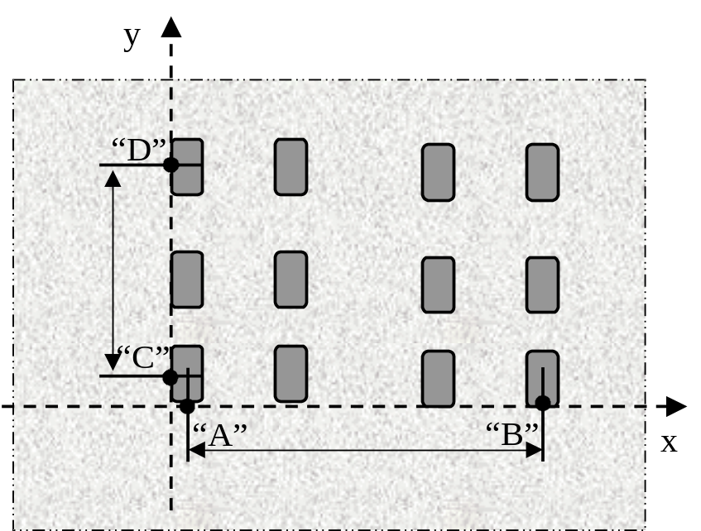
Figure 3. Search Paths for Maximum Stress Location

Calculation of Slab Thickness
The calculated maximum slab edge stress for a specified slab thickness is compared with the maximum allowable stress for the specific PCC. If the calculated maximum stress is significantly different from the maximum allowable stress, the slab thickness is adjusted. For example, the FAA program for rigid airport pavements (R805FAA) [e.] uses an approximation method to estimate PCC edge stresses and obtains PCC thickness by an iterative method. A review of the source code for R805FAA shows that the thickness obtained is then adjusted by a coefficient that is calculated based on the number of aircraft coverages. A similar approach was used in a subroutine of COMFAA, the difference being that the subroutine uses the H51 code for calculating slab edge stresses. The purpose of this subroutine is to find the slab thickness, H_{Slab}, for which the slab edge stress, calculated by COMFAA, satisfies the following equation:

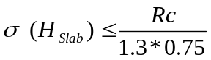 (1)

where: σ(H_{Slab}) Maximum tensile edge stress at the bottom of the slab for slab thickness H_{Slab}.
R_{c} Flexural strength of PCC slab.
1.3 Safety factor.
0.75 Reduction factor based on the assumption that a joint may transfer 25 percent of the load to the other side of the joint.

The slab edge stresses are calculated for gear loads located either parallel or perpendicular to the joint. From the two calculated stresses, the maximum stress is selected, which satisfies equation 1.

A procedure, RTBIS, implementing a bisection method was written to find the slab thickness H_{Slab} for which the maximum slab edge stress is calculated by COMFAA with the precision of 0.01 inch. Figure 4 presents a flowchart for the algorithm implemented in COMFAA.

Initially, the algorithm determines a slab thickness interval within which the solution exists. It then starts a loop. The maximum slab edge stress is evaluated in the middle of the interval. If the maximum stress is higher than the maximum allowable stress, a new interval is taken between the midpoint and the upper bound of the interval and the stress is evaluated at the midpoint of the new interval H_{Slab} = H_{Slab} + DH where DH is half the distance between H_{Slab} and the upper bound of the interval. If the maximum stress is lower than the maximum allowable stress, then the new interval is taken between the lower bound of the interval and the midpoint and the stress is evaluated at the midpoint of the new interval H_{Slab} = H_{Slab} – DH, where DH is half the distance between H_{Slab} and the lower bound of the interval. The loop continues until the size of the interval is smaller than 0.01 inch.

Finally, the slab thickness, H_{Slab}, is adjusted by a factor of a, as applied in the following equation:

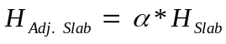 (2)

where α Function for adjusting slab thickness by using the fatigue curve developed by the Corps of Engineers from test track data and observations of in-service pavements. Calculations are made in accordance with the following equations [e.]:

(3)
or
(4)

Figure 5 presents a COMFAA screen with a design thickness result. COMFAA runs calculations for rigid pavements in two different computational modes: ACN Computation Mode and Pavement Design Mode. In the ACN Computation Mode, ACN calculations and slab thickness calculations are based on the slab interior stress [a.]. In the Pavement Design Mode, slab thickness calculations implement the FAA Westergaard edge stress as in the design charts in AC 150/5320-6D [b.].

To choose the computational mode, select the appropriate option button in the computational mode frame, as shown in figure 5. When the option button labeled "ACN Computation" is selected and the button labeled "ACN Rigid" is clicked on, PCC slab thicknesses and ACNs are calculated for four pavement structures having subgrades with specified k values (552.6, 294.7, 147.4, and 73.7 lb/in³- 150.0, 80.0, 40.0, and 20 kg/cm³). These calculations are based on the slab interior stress.
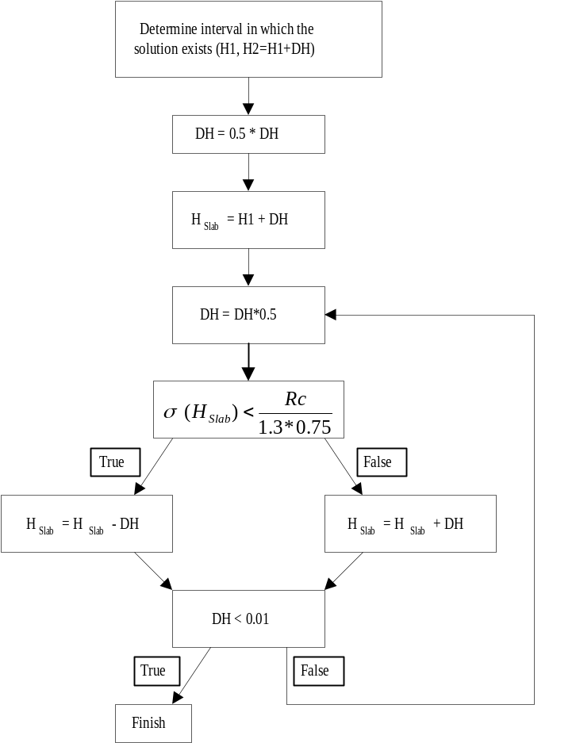
Figure 4. Algorithm for Calculating Slab Thickness

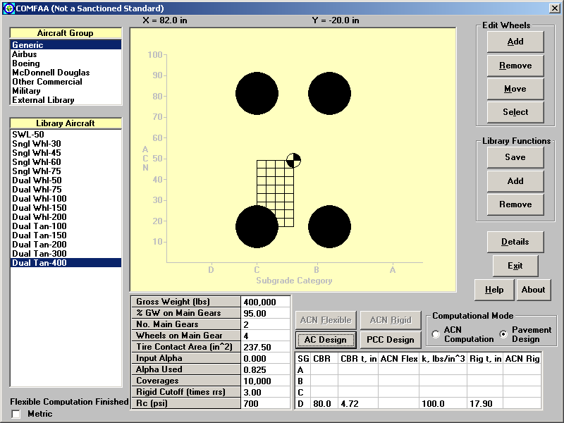
Figure 5. COMFAA Graphic Interface with Design Thickness Result
If the option button labeled "Pavement Design" is selected and the button labeled "Rigid Design" is clicked on, the program computes PCC slab thickness for the k value specified by the user. (To specify the k value, click on the field labeled "k lb/in^3" and type the k value in a message box.) These calculations are based on the slab edge stress.

For the case shown in figure 5, the design thickness of a slab is 17.90 inches (45.47 cm) on a subgrade with a k value of 100 lb/in³ (27.1 kg/cm³) and loaded with a 400,000-pound (181,437 kg) dual tandem gear aircraft at 10,000 coverages, in which the coverages can be obtained from the total pass number divided by the pass/coverage ratio in AC 150/5320-6D [b.].

Reliability of COMFAA
The reliability of COMFAA was checked with respect to the calculation of ACNs, slab edge stress, and slab thickness.

ACNs Calculated Using the COMFAA, ACNR, and ACNF Programs
Appendix C, table C-1, contains a comparison of the ACNs for rigid pavements calculated by COMFAA to those obtained from the ICAO Design Manual [a.]. Appendix C, table C-2, contains a comparison of ACNs for flexible pavements calculated by COMFAA to those obtained from the ICAO Design Manual. From a review of tables C-1 and C-2, it can be concluded that for 27 of the 30 added aircraft, the ACNs calculated using the COMFAA program are similar to the ACNs obtained from the ICAO Design Manual. Significant differences in the ACNs exist only for Canadair CL 44, DC-10-15, and IL76T aircraft. The ACNs for Canadair CL 44 calculated by COMFAA are about 5 points higher than the ACNs obtained from the ICAO Design Manual.

A significant difference of 5.7 points in the ACN number exists for DC-10-15 aircraft on rigid pavements with a subgrade having k=20 MN/m³. Normally, the calculations of ACNs for rigid pavements are done with the default rigid cutoff value of 3. With a rigid cutoff value of 1.23, the ACN number for a rigid pavement with a k=20 MN/m³ subgrade is 72, which is closer to the ICAO Design Manual number of 74 for the DC-10-15.

There are significant differences between ACNs calculated by COMFAA and the ACNs obtained from the ICAO Design Manual for the IL76T aircraft. Moreover, the ACNs for rigid pavements are unreasonable, because the ACN number calculated by COMFAA for a rigid pavement with a subgrade having k=20 MN/m³ is lower than that with a subgrade having k=40 MN/m³. This is contrary to what is expected. The ACN number for aircraft increases when the subgrade in a pavement structure becomes weaker. However, the ICAO numbers for IL76T aircraft for rigid pavements also appear to be unreasonable. The ACNs in this case are almost constant, showing no effect of subgrade strength on the ACNs, contrary to the ACNs for other aircraft.

Tables 2 and 3 show ACNs for the IL76T. Table 2 shows ACNs calculated by COMFAA, where 23.5 percent of the load is on one main gear leg (four main gear legs), as provided by the ICAO Design Manual. Assuming 47 percent (table 3) of the load on one main gear leg (two main gear legs), the calculated ACN numbers are closer to the ICAO ACN numbers. However, there are still significant differences.
Table 2. ACNs for IL76T Aircraft
 | Rigid Pavements |  |  |  | Flexible Pavements
ACN Calculated by the COMFAA Program | 11.0 | 13.2 | 15.4 | 14.4 | 9.0 | 10.3 | 12.5 | 16.5
ACN from the ICAO Design Manual | 38 | 38 | 38 | 39 | 37 | 40 | 45 | 53
Difference in ACN Number | -27.0 | -24.8 | -22.6 | -24.6 | -28.0 | -29.7 | -32.5 | -36.5

Table 3. ACNs for IL76T Aircraft
 | Rigid Pavements |  |  |  | Flexible Pavements
ACN Calculated by the COMFAA Program | 29.4 | 33.1 | 30.0 | 33.8 | 24.1 | 27.3 | 33.8 | 45.4
ACN from the ICAO Design Manual | 38 | 38 | 38 | 39 | 37 | 40 | 45 | 53
Difference in ACN Number | -8.6 | -4.9 | -8.0 | -5.2 | 12.9 | -12.7 | -11.2 | -7.6

The minor differences between ACNs calculated by COMFAA and those obtained from the ICAO Design Manual could be attributed to rounding of the ACNs in the ICAO Design Manual. A comparison with programs ACNR [f.] and ACNF [g.], which are two computer programs developed based on [a.], was made to check for similar differences. The results are presented in tables 4 and 5. For most of the gear configurations, which can be classified as single, dual, tandem, and dual tandem, the differences between the ACNs calculated by COMFAA and those obtained in the ICAO design manual are very small. In most of the cases, ICAO ACNs look like rounded numbers calculated by COMFAA. For example, for flexible pavement (subgrade CBR=15), the COMFAA number for the A310 aircraft is 35.9, the ICAO number is 36, and the ACNF number is 35.80. For a flexible pavement (subgrade CBR=6), the COMFAA ACN number for a DC-10-15 is 73.4, 72 according to the ICAO Design Manual and 73.39 according to ACNF. This indicates that the ACN calculated by ACNF supports those calculated by COMFAA. Therefore, the ACNs calculated by COMFAA can be considered reliable and the program can be used to calculate ACNs for the gear configurations, which can be classified as single, dual, tandem, and dual tandem.

For the complex gear configurations, as shown in appendix D, COMFAA ACNs are either similar to ICAO ACNs and/or to ACNF or ACNR ACNs, except for aircraft Canadair CL 44. For Canadair CL 44 aircraft on rigid pavements, the ICAO ACNs and ACNs calculated by ACNR are similar; however, ACNs calculated by COMFAA are higher. Overall, COMFAA can be used to calculate ACNs for complex configurations, since most ACNs for complex gear configurations calculated by COMFAA are similar to either ICAO ACNs or ACNs calculated by ACNR or ACNF.

Table 4. ACNs for Selected Aircraft on Rigid Pavements
Aircraft Type | ACN by COMFAA |  |  |  | ACN by ICAO Design Man. |  |  |  | ACN by ACNR [f.]
Aircraft Type | Subgrade k [MN/m³] |  |  |  | Subgrade k [MN/m³] |  |  |  | Subgrade k [MN/m³]
Aircraft Type | 150 | 80 | 40 | 20 | 150 | 80 | 40 | 20 | 150 | 80 | 40 | 20
A310 | 32.4 | 38.7 | 46.2 | 53.2 | 33 | 39 | 46 | 54 | 33 | 38.4 | 45.4 | 52.3
A320 DT | 16.5 | 19.8 | 23.6 | 27.2 | 18 | 21 | 24 | 28 | 16.7 | 19.7 | 23.3 | 26.9
Caravelle 10 | 13.7 | 16.4 | 19.3 | 21.9 | 15 | 17 | 20 | 22 | 32.8 | 33.7 | 34.7 | 35.6
Canadair CL 44 | 30.0 | 35.2 | 40.6 | 45.4 | 25 | 30 | 35 | 40 | 25.3 | 29.9 | 35.4 | 40.5
CV 880 M | 25.8 | 30.8 | 35.8 | 40.3 | 26 | 31 | 36 | 41 | 25.7 | 30.0 | 34.9 | 39.3
MD-87 | 43.7 | 46.0 | 48.0 | 49.7 | 45 | 47 | 49 | 50 | 43.7 | 46.0 | 48.1 | 49.7
DC-10-15 | 48.5 | 57.2 | 68.5 | 79.7 | 48 | 56 | 67 | 74 | 48.7 | 56.3 | 67.0 | 78.0
IL76T | 11.0 | 13.2 | 15.4 | 14.4 | 38 | 38 | 38 | 39 | 10.9 | 12.2 | 14.0 | 13.6
L1011-1 | 44.3 | 51.7 | 61.7 | 72.2 | 45 | 52 | 62 | 73 | 46.3 | 51.9 | 61.1 | 71.3
TU154B | 17.5 | 23.8 | 30.4 | 36.2 | 19 | 25 | 32 | 38 | 15.8 | 18.2 | 23.6 | 29.0

Table 5. ACNs for Selected Aircraft on Flexible Pavements
Aircraft Type | ACN by COMFAA |  |  |  | ACN by ICAO Design Man. |  |  |  | ACN by ACNF [g.]
Aircraft Type | Subgrade CBR |  |  |  | Subgrade CBR |  |  |  | Subgrade CBR
Aircraft Type | 15 | 10 | 6 | 3 | 15 | 10 | 6 | 3 | 15 | 10 | 6 | 3
A310 | 35.9 | 39.7 | 48.1 | 63.2 | 36 | 40 | 48 | 64 | 35.80 | 39.73 | 48.11 | 63.18
A320 DT | 17.6 | 19.2 | 23.1 | 31.7 | 18 | 19 | 23 | 32 | 17.63 | 19.22 | 23.06 | 31.69
Caravelle 10 | 14.7 | 16.5 | 19.3 | 23.1 | 15 | 17 | 19 | 23 | 13.88 | 15.49 | 18.72 | 22.89
Canadair CL 44 | 31.5 | 35.6 | 40.3 | 48.1 | 27 | 30 | 36 | 47 | 31.52 | 35.61 | 40.27 | 48.13
CV 880 M | 26.5 | 30.6 | 35.7 | 44.0 | 27 | 31 | 36 | 44 | 26.53 | 30.62 | 35.77 | 43.98
MD-87 | 38.6 | 41.1 | 46.0 | 49.2 | 39 | 42 | 46 | 50 | 37.89 | 39.13 | 42.59 | 46.42
DC-10-15 | 55.8 | 61.5 | 73.4 | 100.2 | 55 | 61 | 72 | 100 | 55.39 | 60.85 | 72.15 | 98.88
IL76T | 9.0 | 10.4 | 12.5 | 16.5 | 37 | 40 | 45 | 53 | 8.23 | 9.31 | 10.90 | 13.96
L1011-1 | 51.9 | 56.4 | 66.1 | 90.2 | 52 | 56 | 66 | 91 | 51.95 | 56.42 | 66.13 | 90.19
TU154B | 19.2 | 22.4 | 28.4 | 37.1 | 20 | 24 | 30 | 38 | 19.16 | 22.35 | 28.35 | 37.02

ACN Numbers for C-17A on Rigid Pavements
In the case of the C-17A, COMFAA provides inconsistent results for ACNs for rigid pavements on high and medium strength subgrades, as shown in figure 6. Calculations of ACNs for rigid pavements use a rigid cutoff value of 3, which is the standard for the ICAO computation of ACNs. Increasing the value of the rigid cutoff gives consistent results, as shown in table 6, but this procedure is not standard.

To fully understand the impact of changes in the rigid cutoff value on ACNs, calculations of ACNs were made with different rigid cutoff values for two types of gear loadings, as shown in figures 6 and 7. The ACNs are presented in Tables 6 and 7. Table 6 presents ACNs for the C-17A. Table 7 presents ACNs for three out of six wheels of the C-17A. Tables 6 and 7 show that, for certain rigid cutoff values and certain subgrade strengths, ACNs for both gear configurations can be identical. For example, with a rigid cutoff value of 2 and a subgrade strength of 150 pci (40.7 kg/cm³), the ACN for both gear configurations is 57.7. For the C-17A, an increase in the rigid cutoff value causes changes in ACNs by the inclusion of additional wheels in the calculation of the ACNs. It can be concluded that in the case of inconsistent ACN values for certain gear configurations, consistency can be achieved by increasing the value of the rigid cutoff.

Table 6. ACNs for C-17A Aircraft on Rigid Pavements
k [kg/cm³] | Rigid Cutoff
k [kg/cm³] | 1 | 1.5 | 2 | 2.5 | 3 | 3.5 | 4
150 | 38.0 | 56.9 | 57.7 | 57.7 | 53.5 | 45.0 | 43.5
80 | 38.4 | 64.9 | 64.9 | 56.4 | 48.2 | 47.8 | 47.8
40 | 71.5 | 71.6 | 62.4 | 56.7 | 56.7 | 56.7 | 56.7
20 | 77.1 | 72.8 | 70.6 | 70.6 | 70.6 | 70.6 | 70.6

Table 7. ACNs for Three out of Six Wheels for C-17A Aircraft on Rigid Pavements
k [kg/cm³] | Rigid Cutoff
k [kg/cm³] | 1 | 1.5 | 2 | 2.5 | 3 | 3.5 | 4
150 | 38.0 | 56.9 | 57.7 | 57.7 | 57.7 | 57.7 | 57.7
80 | 38.4 | 64.9 | 64.9 | 64.9 | 64.9 | 64.9 | 64.9
40 | 71.5 | 71.6 | 71.6 | 71.6 | 71.6 | 71.6 | 71.6
20 | 77.1 | 77.1 | 77.1 | 77.1 | 77.1 | 77.1 | 77.1

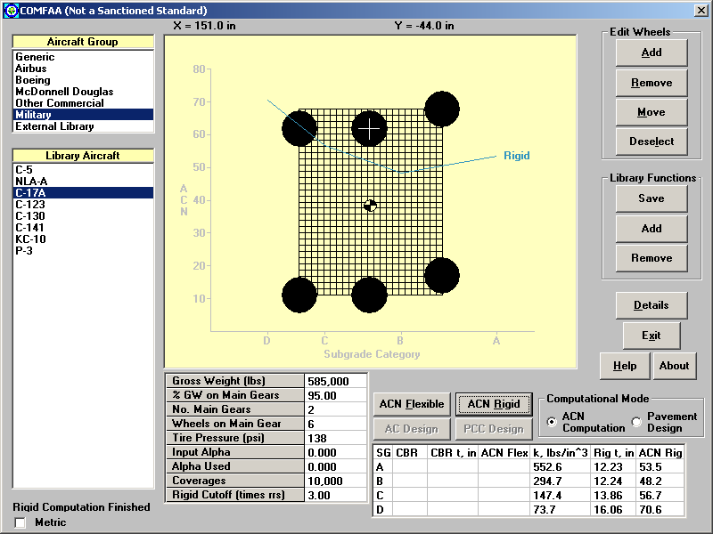
Figure 6. COMFAA Results for C-17A Aircraft

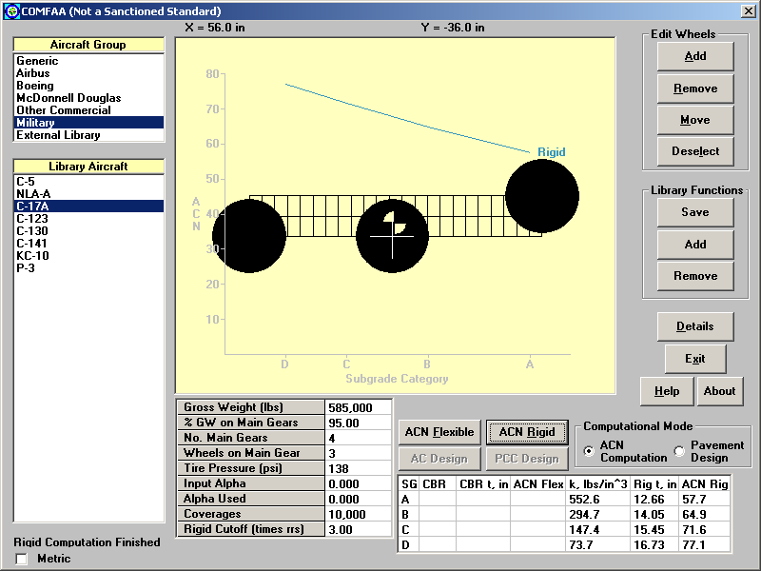
Figure 7. COMFAA Results for Three Wheels out of Six on C-17A Aircraft

Slab Thickness Calculated Using COMFAA and AC 150/5320-6D
Seven cases were analyzed to compare the design thicknesses obtained from COMFAA, AC 150/5320-6D, and R805FAA. The input data for these cases are included in table 8. Table 9 presents a comparison of design thicknesses obtained from the three sources. The last column in table 9 shows the difference between the design thickness obtained from R805FAA and from COMFAA.

Table 8. Input Data for Thickness Designs
No. | Aircraft/Gear Configuration | Annual Departures | Pass/Cov. Ratio | Coverages¹ | k | Concrete  Flexural  Strength | Gear Weight | Tire Contact Area
 |  |  |  |  | lb/in³ | psi | lbs | in²
1 | Single Wheel | 1200 | 5.18 | 4,633 | 100 | 750 | 35,625 | 296.87
2 | Dual Wheel | 1200 | 3.48 | 6,897 | 100 | 750 | 95,000 | 237.50
3 | Dual Tandem | 6000 | 3.68 | 32,609 | 200 | 700 | 190,000 | 237.50
4 | A-300 Model B2 | 6000 | 3.51 | 34,188 | 200 | 700 | 142,500 | 207.47
5 | B-747 SP | 15000 | 3.70 | 81,081 | 50 | 800 | 166,250 | 210.00
6 | B-767 | 25000 | 3.90 | 128,205 | 300 | 650 | 142,500 | 202.46
7 | DC-10-10 | 25000 | 3.64 | 137,363 | 300 | 650 | 213,750 | 294.00
¹Coverages are determined by multiplying annual departures by 20 and dividing that product by the pass-to-coverage ratio [b.].

Table 9. Results of Thickness Designs
No. | Aircraft/Gear Configuration | Design Thickness - H (inches) |  |  | Difference (inches)  H_{R805FAA} - H_{COMFAA}
No. | Aircraft/Gear Configuration | 6D | R805FAA | COMFAA | Difference (inches)  H_{R805FAA} - H_{COMFAA}
1 | Single Wheel | 10.2 | 10.00 | 9.98 | 0.02
2 | Dual Wheel | 15.3 | 15.42 | 15.30 | 0.12
3 | Dual Tandem | 17.0 | 16.99 | 16.65 | 0.34
4 | A-300 Model B2 | 13.0 | 12.96 | 12.72 | 0.24
5 | B-747 SP | 17.8 | 17.55 | 17.43 | 0.12
6 | B-767 | 12.4 | 12.62 | 12.54 | 0.08
7 | DC-10-10 | 15.5 | 15.27 | 15.12 | 0.15

An additional investigation was conducted to see if there are any differences between the design thicknesses calculated by AC 150/5320-6C and those calculated by COMFAA. Overall, from tables 9 and 10, it can be observed that the thicknesses calculated by the two methods are in agreement. It can be concluded that COMFAA produces acceptable results.

Table 10. Comparison of Design Thicknesses Obtained by AC 150/5320-6C and COMFAA
Major Input Data | Tools | Annual Passes (1000)
Major Input Data | Tools | 1.2 | 3.0 | 6.0 | 15.0 | 25.0
B-747-100, GW=800kp  R = 700psi, k=350 pci | FAA-6C | 11.9 | 12.6 | 13.2 | 14 | 14.4
B-747-100, GW=800kp  R = 700psi, k=350 pci | ACNComp | 11.9 | 12.6 | 13.2 | 13.9 | 14.3
DC-10-10, GW=400kp  R=800psi, k=50 pci | FAA-6C | 14.8 | 15.3 | 16 | 16.9 | 17.3
DC-10-10, GW=400kp  R=800psi, k=50 pci | ACNComp | 14.4 | 15.3 | 16.0 | 16.8 | 17.3
L1011-100, GW=500kp  R = 735 psi, k=100 pci | FAA-6C | 12.8 | 13.7 | 14.2 | 15 | 15.5
L1011-100, GW=500kp  R = 735 psi, k=100 pci | ACNComp | 12.8 | 13.6 | 14.2 | 14.9 | 15.4

Analysis of Two Closely Spaced Triple Twin Tandems Using COMFAA
Figure 8 presents dimensions of two closely spaced triple twin tandems, which are analyzed with COMFAA. The purpose of the analysis is to determine the impact of a second triple twin tandem on the maximum slab edge stress. The single tire load for the analyzed case is 58,852 pounds (26,695 kg) and the tire pressure is 194 psi (1338 kPa).

Figures 9 and 10 show the results for two cases: Case 1 ― slab thickness 14.90 inches (37.85 cm), subgrade modulus k = 100 pci (27.1 kg/cm³), and Case 2 ― slab thickness 12.62 inches (32.05 cm), subgrade modulus k = 200 pci (54.3 kg/cm³).

Figures 9 and 10 show the contribution of each individual wheel to the maximum slab edge stress at the bottom of the slab. In both cases, the contribution of one triple twin tandem to the maximum slab edge stress is significant, while the contribution of a second triple twin tandem is negligible. It can be concluded that it is sufficient to consider only one triple twin tandem when determining the maximum slab edge stress using the H51 model.

The contribution of a single wheel to the edge stress, based on the location of the wheel, is shown in figures 11 and 12. The wheel is positioned perpendicular to the slab edge. The figures show that the contribution of the wheel to the edge stress is insignificant when the wheel is located more than 190 inches (482.6 cm) from the point of edge stress evaluation.

60.24”
60.24”
147.00”
66.93”
66.93”
60.24”
60.24”
61.02”
61.02”
207.24”

Figure 8. Two Closely Spaced Triple Twin Tandems

1
-47.4
2
8.8
3
-1.1
4
0.0
5
668.1
6
128.4
7
0.8
8
0.0
9
-47.3
10
8.9
11
-1.1
12
0.0
"A"

Figure 9. Contribution of Individual Wheels to Slab Edge Stress at Location "A" for Two Triple Twin Tandems (Slab Thickness = 14.90 inches (37.85 cm), k = 100 pci (27.1 kg/cm³))

1
735.8
2
-87.9
3
0.0
4
0.0
5
71.8
6
-3.3
7
0.0
8
0.0
9
3.3
10
-2.0
11
0.0
12
0.0
"A"

Figure 10. Contribution of Individual Wheels to Slab Edge Stress at Location "A" for Two Triple Twin Tandems (Slab Thickness = 12.62 inches (32.05 cm), k = 200 pci (54.3 kg/cm³))

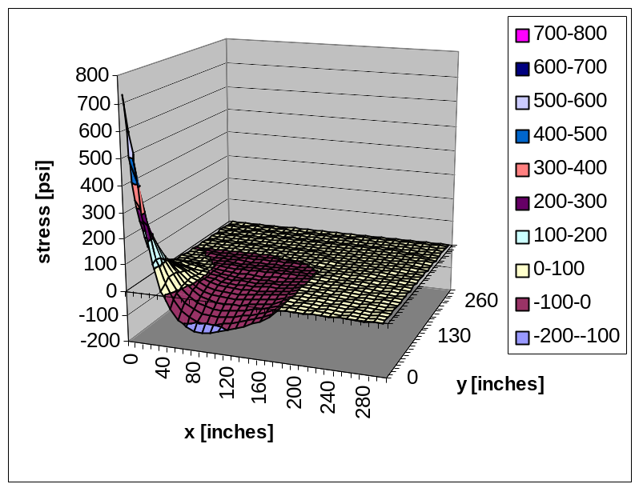
Figure 11. 3-D Surface of Edge Stress Depending on Wheel Position at Coordinates x and y (Slab Thickness = 12.62 inches (32.05 cm), k = 200 pci (54.3 kg/cm³))

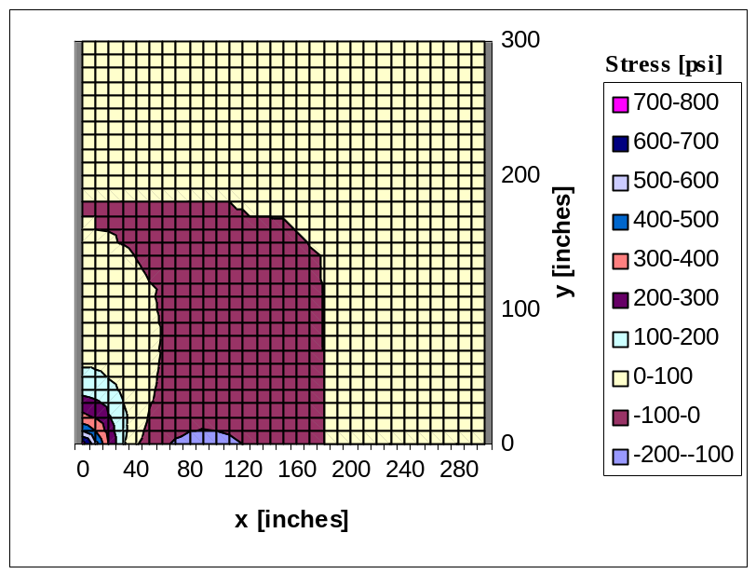
Figure 12. Surface Chart, Viewed from Above, of Edge Stress Depending on Wheel Position at Coordinates x and y (Slab Thickness = 12.62 inches (32.05 cm), k = 200 pci (54.3 kg/cm³))

REFERENCES
- "Aerodrome Design Manual: Part 3 Pavements," Second Edition, Doc. 9157-AN/901, Part 3, International Civil Aviation Organization, 1983.
- "Airport Pavement Design and Evaluation," AC 150/5320-6D, July 7, 1995.
- Kreger, W.C., "Computerized Aircraft Ground Flotation Analysis-Edge-Loaded Rigid Pavement," General Dynamics Research Program, Task RDP 414-61-506, January 1967.
- Press, W.H., Flannery B.P., Teukolsky, S.A., and Vettering, W.T., "Numerical Recipes: The Art of Scientific Computing," Cambridge University Press, 1986.
- R805FAA Computer Program "Computer Aided Design for Rigid Airport Pavements (R805FAA)," U.S. Department of Transportation, Federal Aviation Administration, Washington, D.C., May 31, 1988.
- ACNR Computer Program "ICAO Aircraft Classification Number (ACN) Analysis for Aerodrome Pavements," International Civil Aviation Organization (ICAO), Aerodromes, Air Routes and Ground Aids Section.
- ACNF Computer Program "ICAO Aircraft Classification Number (ACN) Analysis for Aerodrome Pavements," International Civil Aviation Organization (ICAO), Aerodromes, Air Routes and Ground Aids Section.
APPENDIX A ⎯ CHARACTERISTICS OF AIRCRAFT ADDED TO COMFAA

No. | Aircraft Type | Wheel Arrangement | Gear Load |  | Load on One Main Gear | Tire Pressure |  |  | Wheel Spacing
No. | Aircraft Type | Wheel Arrangement | kg | lbs | Load on One Main Gear | Mpa | psi |  | Transverse |  | Longitudinal
 |  |  |  |  |  |  |  |  | cm | in | cm | in
1 | A-310-200 | Dual Tandem | 132,000 | 291,010 | 0.467 | 1.23 |  | 178 | 93 | 36.6 | 140 | 55.1
2 | A-320 Dual Tandem | Dual Tandem | 68,000 | 149,914 | 0.471 | 1.12 |  | 162 | 78 | 30.7 | 100 | 39.4
3 | B720 | Dual Tandem | 104,326 | 229,999 | 0.474 | 1 |  | 145 | 81 | 31.9 | 124 | 48.8
4 | DC-3 | Single | 11,430 | 25,199 | 0.468 | 0.31 |  | 45 | - | - | - | -
5 | DC-4 | Dual | 33,113 | 73,002 | 0.468 | 0.53 |  | 77 | 74 | 29.1 | - | -
6 | DC-8-43 | Dual Tandem | 144,242 | 317,999 | 0.465 | 1.22 |  | 177 | 76 | 29.92 | 140 | 55.12
7 | DC-10-15 | Dual Tandem | 207,746 | 458,002 | 0.467 | 1.34 |  | 194 | 137 | 53.9 | 163 | 64.2
8 | MD-87 | Dual | 68,266 | 150,501 | 0.474 | 1.17 |  | 170 | 71 | 28.0 | - | -
9 | BAC 1-11 Series 400 | Dual | 39,690 | 87,501 | 0.475 | 0.93 |  | 135 | 53 | 20.9 | - | -
10 | BAC 1-11 Series 475 | Dual | 44,679 | 98,500 | 0.475 | 0.57 |  | 83 | 62 | 24.4 | - | -
11 | Caravelle 10 | Complex see Table 3 | 52,000 | 114,640 | 0.461 | 0.75 |  | 109 | 40 | 15.7 | 107 | 42.1
12 | Caravelle 12 | Complex see Table 3 | 55,960 | 123,371 | 0.46 | 0.88 |  | 128 | 41 | 16.1 | 107 | 42.1
13 | Canadair CL 44 | Complex see Table 3 | 95,708 | 211,000 | 0.475 | 1.12 |  | 162 | 51 | 20.1 | 122 | 48
14 | CV 880 M | Dual Tandem | 87,770 | 193,500 | 0.466 | 1.03 |  | 149 | 55 | 21.7 | 114 | 44.9
15 | CV 990 | Dual Tandem | 115,666 | 255,000 | 0.485 | 1.28 |  | 186 | 61 | 24.0 | 118 | 46.5
16 | Dash 7 | Dual | 19,867 | 43,799 | 0.468 | 0.74 |  | 107 | 42 | 16.5 | - | -
17 | F27 Friendship  Mk500 | Dual | 19,777 | 43,601 | 0.475 | 0.54 |  | 78 | 45 | 17.7 | - | -
18 | F28 Fellowship  Mk1000LPT | Dual | 29,484 | 65,001 | 0.463 | 0.58 |  | 84 | 58 | 22.8 | - | -
19 | F28 Fellowship  Mk1000HTP | Dual | 29,484 | 65,001 | 0.463 | 0.69 |  | 100 | 55 | 21.7 | - | -
20 | Fokker 100 | Dual | 44,680 | 98,503 | 0.478 | 0.98 |  | 142 | 59 | 23.2 | - | -
21 | HS125 | Dual | 10,600 | 23,369 | 0.455 | 0.77 |  | 112 | 32 | 12.6 | - | -
22 | HS748 | Dual | 21,092 | 46,500 | 0.436 | 0.59 |  | 86 | 48 | 18.9 | - | -
23 | IL62 | Dual Tandem | 162,600 | 358,472 | 0.47 | 1.08 |  | 157 | 80 | 31.5 | 165 | 65
24 | IL76T | Complex see Table 3 | 171,000 | 376,990 | 0.235 | 0.64 |  | 93 | - | - | 258 | 101.6
25 | IL86 | 3 DT Units | 209,500 | 461,868 | 0.312 | 0.88 |  | 128 | 125 | 49.2 | 149 | 58.7
26 | L-100-20 | Tandem | 70,670 | 155,801 | 0.482 | 0.72 |  | 104 | - | - | 154 | 60.6
27 | Trident 1E | Complex see Table 3 | 61,160 | 134,835 | 0.46 | 1.03 |  | 149 | 32 | 12.6 | - | -
28 | TU134A | Dual Tandem | 47,600 | 104,940 | 0.456 | 0.83 |  | 120 | 56 | 22.0 | 99 | 39
29 | TU154B | Complex see Table3 | 98,000 | 216,053 | 0.451 | 0.93 |  | 135 | 62 | 24.4 | 98 | 38.6
30 | VC10-1150 | Dual Tandem | 151,953 | 334,999 | 0.483 | 1.01 |  | 146 | 86 | 33.9 | 155 | 61

APPENDIX B ⎯ COMPARISON OF RESULTS CALCULATED BY H51 FORTRAN AND VISUAL BASIC VERSIONS

Listing B.1 TestH51 Input Data for A-300-600 Aircraft

A-300-600
Runway Characteristics:
H K E MU RO DELTA
10 200 4000000 0.15 36.1354107661622 0
XLA, XLB, XLC, XLD = 27 0 65 0
XNA, XNB, XNC, XND = 2 1 2 1
Contact area of one tire = 232.427777777778 PHIE = 1.667
Inflation Pressure = 180 psi.
Gear Load = 167348 lb B = 150

Listing B.2 TestH51 Input Data for B-777-200 Aircraft

B-777-200
Runway Characteristics:
H K E MU RO DELTA
10 200 4000000 0.15 36.1354107661622 0
XLA, XLB, XLC, XLD = 56 0 65 0
XNA, XNB, XNC, XND = 2 1 3 1
Contact area of one tire = 491.758241758242 PHIE = 1.667
Inflation Pressure = 182 psi.
Gear Load = 537000 lb B = 150

Listing B.3 TestH51 Input Data for IL76 Aircraft

IL76
Runway Characteristics:
H K E MU RO DELTA
30 200 4000000 0.15 82.3709238474263 0
XLA, XLB, XLC, XLD = 24 56 58 0
XNA, XNB, XNC, XND = 2 2 2 1
Contact area of one tire = 320.245879120879 PHIE = 1.667
Inflation Pressure = 182 psi.
Gear Load = 466278 lb B = 150

Table B-1. Results for A-300-600 Aircraft
No. | Slab Thickness (in) | GAMMA (degree) | Stress FORTRAN (psi) | Stress Vbasic (psi) | Difference
1 | 10 | 0 | 1004.578 | 1004.575871 | -0.000212%
2 |  | 60 | 1054.291 | 1054.288455 | -0.000241%
3 |  | 90 | 945.305 | 945.3054643 | 0.000049%
4 | 12 | 0 | 814.717 | 814.7168406 | -0.000020%
5 |  | 60 | 833.604 | 833.6041241 | 0.000015%
6 |  | 90 | 755.909 | 755.9095996 | 0.000079%
7 | 20 | 0 | 436.917 | 436.9165003 | -0.000114%
8 |  | 60 | 426.846 | 426.8469253 | 0.000217%
9 |  | 90 | 397.995 | 397.9954854 | 0.000122%
10 | 28 | 0 | 274.251 | 274.2508386 | -0.000059%
11 |  | 60 | 267.526 | 267.5260023 | 0.000001%
12 |  | 90 | 255.716 | 255.7161598 | 0.000062%
13 | 30 | 0 | 248.5 | 248.4995994 | -0.000161%
14 |  | 60 | 241.918 | 241.9179881 | -0.000005%
15 |  | 90 | 232.326 | 232.3262948 | 0.000127%

Table B-2. Results for B-777-200 Aircraft
No. | Slab Thickness (in) | GAMMA (degree) | Stress FORTRAN (psi) | Stress Vbasic (psi) | Difference
1 | 10 | 0 | 1220.749 | 1220.750891 | 0.000155%
2 |  | 60 | 1391.675 | 1391.674807 | -0.000014%
3 |  | 90 | 972.494 | 972.491089 | -0.000299%
4 | 12 | 0 | 1021.577 | 1021.578512 | 0.000148%
5 |  | 60 | 1122.404 | 1122.402727 | -0.000113%
6 |  | 90 | 866.44 | 866.4401079 | 0.000012%
7 | 20 | 0 | 625.238 | 625.2371494 | -0.000136%
8 |  | 60 | 624.298 | 624.2977675 | -0.000037%
9 |  | 90 | 614.193 | 614.1912793 | -0.000280%
10 | 28 | 0 | 440.431 | 440.4310881 | 0.000020%
11 |  | 60 | 426.891 | 426.8905455 | -0.000106%
12 |  | 90 | 458.038 | 458.0367487 | -0.000273%
13 | 30 | 0 | 406.216 | 406.2166814 | 0.000168%
14 |  | 60 | 392.912 | 392.9105134 | -0.000378%
15 |  | 90 | 423.834 | 423.8327699 | -0.000290%

Table B-3. Results for Il76 Aircraft
No. | Slab Thickness (in) | GAMMA (degree) | Stress FORTRAN (psi) | Stress Vbasic (psi) | Difference
1 | 10 | 0 | 1009.358 | 1009.359067 | 0.000106%
2 |  | 60 | 1142.154 | 1142.155404 | 0.000123%
3 |  | 90 | 1061.429 | 1061.428613 | -0.000036%
4 | 12 | 0 | 887.207 | 887.207818 | 0.000092%
5 |  | 60 | 957.422 | 957.4172015 | -0.000501%
6 |  | 90 | 891.804 | 891.8048697 | 0.000098%
7 | 20 | 0 | 598.529 | 598.5295578 | 0.000093%
8 |  | 60 | 571.907 | 571.9084047 | 0.000246%
9 |  | 90 | 551.281 | 551.2808991 | -0.000018%
10 | 28 | 0 | 432.974 | 432.9747341 | 0.000170%
11 |  | 60 | 397.195 | 397.1953286 | 0.000083%
12 |  | 90 | 385.973 | 385.9738452 | 0.000219%
13 | 30 | 0 | 399.173 | 399.1730765 | 0.000019%
14 |  | 60 | 366.971 | 366.9717046 | 0.000192%
15 |  | 90 | 357.659 | 357.6590433 | 0.000012%

APPENDIX C ⎯ RIGID AND FLEXIBLE PAVEMENT ACNS FOR AIRCRAFT ADDED TO COMFAA

Table C-1. ACNs for Added Aircraft on Rigid Pavements

No. | Aircraft Type | ACN by COMFAA |  |  |  | ACN by ICAO Design Man. |  |  |  | Difference in ACN Number
No. | Aircraft Type | Subgrade k [MN/m³] |  |  |  | Subgrade k [MN/m³] |  |  |  | Subgrade k [MN/m³]
No. | Aircraft Type | 150 | 80 | 40 | 20 | 150 | 80 | 40 | 20 | 150 | 80 | 40 | 20
1 | A-310-200 | 32.4 | 38.7 | 46.2 | 53.2 | 33 | 39 | 46 | 54 | -0.6 | -0.3 | 0.2 | -0.8
2 | A-320 Dual Tandem | 16.5 | 19.8 | 23.6 | 27.2 | 18 | 21 | 24 | 28 | -1.5 | -1.2 | -0.4 | -0.8
3 | B720 | 25.2 | 30.8 | 37.2 | 42.9 | 25 | 30 | 37 | 42 | 0.2 | 0.8 | 0.2 | 0.9
4 | DC-3 | 6.0 | 6.5 | 6.9 | 7.2 | 6 | 7 | 7 | 7 | 0.0 | -0.5 | -0.1 | 0.2
5 | DC-4 | 13.2 | 14.9 | 16.6 | 17.9 | 13 | 15 | 17 | 18 | 0.2 | -0.1 | -0.4 | -0.1
6 | DC-8-43 | 41 | 49 | 57 | 65 | 40.7 | 48.7 | 57.1 | 64.6 | 0.3 | 0.3 | -0.1 | 0.4
7 | DC-10-15 | 48.5 | 57.2 | 68.5 | 79.7 | 48 | 56 | 67 | 74 | 0.5 | 1.2 | 1.5 | 5.7
8 | MD-87 | 43.7 | 46.0 | 48.0 | 49.7 | 45 | 47 | 49 | 50 | -1.3 | -1.0 | -1.0 | -0.3
9 | BAC 1-11 Series 400 | 24.8 | 26.2 | 27.5 | 28.5 | 25 | 26 | 28 | 29 | -0.2 | 0.2 | -0.5 | -0.5
10 | BAC 1-11 Series 475 | 22.6 | 24.8 | 26.8 | 28.4 | 22 | 25 | 27 | 28 | 0.6 | -0.2 | -0.2 | 0.4
11 | Caravelle 10 | 13.7 | 16.4 | 19.3 | 21.9 | 15 | 17 | 20 | 22 | -1.3 | -0.6 | -0.7 | -0.1
12 | Caravelle 12 | 16.4 | 19.3 | 22.3 | 25.0 | 16 | 19 | 22 | 25 | 0.4 | 0.3 | 0.3 | 0.0
13 | Canadair CL 44 | 30.0 | 35.2 | 40.6 | 45.4 | 25 | 30 | 35 | 40 | 5.0 | 5.2 | 5.6 | 5.4
14 | CV 880 M | 25.8 | 30.8 | 35.8 | 40.3 | 26 | 31 | 36 | 41 | -0.2 | -0.2 | -0.2 | -0.7
15 | CV 990 | 40.4 | 47.3 | 54.1 | 59.9 | 41 | 48 | 54 | 60 | -0.6 | -0.7 | 0.1 | -0.1
16 | Dash 7 | 11.2 | 12.0 | 12.6 | 13.2 | 11 | 12 | 13 | 13 | 0.2 | 0.0 | -0.4 | 0.2
17 | F27 Friendship  Mk500 | 9.9 | 10.9 | 11.7 | 12.3 | 10 | 11 | 12 | 12 | -0.1 | -0.1 | -0.3 | 0.3
18 | F28 Fellowship  Mk1000LPT | 13.7 | 15.1 | 16.4 | 17.4 | 14 | 15 | 17 | 18 | -0.3 | 0.1 | -0.6 | -0.6
19 | F28 Fellowship  Mk1000HTP | 15.0 | 16.3 | 17.4 | 18.4 | 15 | 16 | 18 | 18 | 0.0 | 0.3 | -0.6 | 0.4
20 | Fokker 100 | 27.7 | 29.3 | 30.8 | 31.9 | 28 | 29 | 31 | 32 | -0.3 | 0.3 | -0.2 | -0.1
21 | HS125 | 5.9 | 6.3 | 6.6 | 6.8 | 6 | 6 | 7 | 7 | -0.1 | 0.3 | -0.4 | -0.2
22 | HS748 | 9.6 | 10.5 | 11.3 | 11.9 | 10 | 11 | 11 | 12 | -0.4 | -0.5 | 0.3 | -0.1
23 | IL62 | 41.6 | 50.1 | 59.7 | 68.6 | 42 | 50 | 60 | 69 | -0.4 | 0.1 | -0.3 | -0.4
24 | IL76T | 11.0 | 13.2 | 15.4 | 14.4 | 38 | 38 | 38 | 39 | -27.0 | -24.8 | -22.6 | -24.6
25 | IL86 | 25.6 | 30.7 | 37.9 | 45.7 | 25 | 31 | 38 | 46 | 0.6 | -0.3 | -0.1 | -0.3
26 | L-100-20 | 30.2 | 32.7 | 35.5 | 38.2 | 30 | 33 | 36 | 38 | 0.2 | -0.3 | -0.5 | 0.2
27 | Trident 1E | 31.8 | 34.3 | 36.5 | 38.4 | 32 | 34 | 37 | 39 | -0.2 | 0.3 | -0.5 | -0.6
28 | TU134A | 10.3 | 12.6 | 15.2 | 17.7 | 11 | 13 | 16 | 19 | -0.7 | -0.4 | -0.8 | -1.3
29 | TU154B | 17.5 | 23.8 | 30.4 | 36.2 | 19 | 25 | 32 | 38 | -1.5 | -1.2 | -1.6 | -1.8
30 | VC10-1150 | 37.5 | 45.9 | 55.5 | 64.2 | 38 | 46 | 56 | 65 | -0.5 | -0.1 | -0.5 | -0.8
Table C-2. ACNs for Added Aircraft on Flexible Pavements

No. | Aircraft Type | ACN by COMFAA |  |  |  | ACN by ICAO Design Manual |  |  |  | Difference in ACN Number
No. | Aircraft Type | Subgrade CBR |  |  |  | Subgrade CBR |  |  |  | Subgrade CBR
No. | Aircraft Type | 15 | 10 | 6 | 3 | 15 | 10 | 6 | 3 | 15 | 10 | 6 | 3
1 | A-310-200 | 35.9 | 39.7 | 48.1 | 63.2 | 36 | 40 | 48 | 64 | -0.1 | -0.3 | 0.1 | -0.8
2 | A-320 Dual Tandem | 17.6 | 19.2 | 23.1 | 31.7 | 18 | 19 | 23 | 32 | -0.4 | 0.2 | 0.1 | -0.3
3 | B720 | 28.6 | 31.7 | 39.3 | 51.3 | 29 | 31 | 39 | 51 | -0.4 | 0.7 | 0.3 | 0.3
4 | DC-3 | 3.9 | 5.5 | 7.5 | 9.2 | 4 | 6 | 8 | 9 | -0.1 | -0.5 | -0.5 | 0.2
5 | DC-4 | 12.3 | 14.0 | 16.5 | 20.4 | 11 | 14 | 16 | 20 | 1.3 | 0.0 | 0.5 | 0.4
6 | DC-8-43 | 43 | 49 | 59 | 74 | 43.1 | 49.5 | 58.8 | 73 | -0.1 | -0.5 | 0.2 | 1.0
7 | DC-10-15 | 55.8 | 61.5 | 73.4 | 100.2 | 55 | 61 | 72 | 100 | 0.8 | 0.5 | 1.4 | 0.2
8 | MD-87 | 38.6 | 41.1 | 46.0 | 49.2 | 39 | 42 | 46 | 50 | -0.4 | -0.9 | 0.0 | -0.8
9 | BAC 1-11 Series 400 | 22.1 | 23.9 | 26.7 | 28.6 | 22 | 24 | 27 | 29 | 0.1 | -0.1 | -0.3 | -0.4
10 | BAC 1-11 Series 475 | 19.2 | 24.1 | 27.5 | 31.1 | 19 | 24 | 28 | 31 | 0.2 | 0.1 | -0.5 | 0.1
11 | Caravelle 10 | 14.7 | 16.5 | 19.3 | 23.1 | 15 | 17 | 19 | 23 | -0.3 | -0.5 | 0.3 | 0.1
12 | Caravelle 12 | 17.1 | 19.0 | 21.6 | 25.6 | 17 | 19 | 21 | 26 | 0.1 | 0.0 | 0.6 | -0.4
13 | Canadair CL 44 | 31.5 | 35.6 | 40.3 | 48.1 | 27 | 30 | 36 | 47 | 4.5 | 5.6 | 4.3 | 1.1
14 | CV 880 M | 26.5 | 30.6 | 35.7 | 44.0 | 27 | 31 | 36 | 44 | -0.5 | -0.4 | -0.3 | 0.0
15 | CV 990 | 39.9 | 45.7 | 53.0 | 64.0 | 40 | 45 | 53 | 64 | -0.1 | 0.7 | 0.0 | 0.0
16 | Dash 7 | 9.5 | 10.7 | 12.3 | 13.7 | 10 | 11 | 12 | 14 | -0.5 | -0.3 | 0.3 | -0.3
17 | F27 Friendship  Mk500 | 7.9 | 9.8 | 11.6 | 13.4 | 8 | 10 | 12 | 13 | -0.1 | -0.2 | -0.4 | 0.4
18 | F28 Fellowship  Mk1000LPT | 11.3 | 14.1 | 16.3 | 19.3 | 11 | 14 | 16 | 19 | 0.3 | 0.1 | 0.3 | 0.3
19 | F28 Fellowship  Mk1000HTP | 12.9 | 15.0 | 17.2 | 19.7 | 13 | 15 | 17 | 20 | -0.1 | 0.0 | 0.2 | -0.3
20 | Fokker 100 | 24.7 | 26.4 | 29.8 | 32.2 | 25 | 27 | 30 | 32 | -0.3 | -0.6 | -0.2 | 0.2
21 | HS125 | 4.8 | 5.4 | 6.3 | 7.0 | 5 | 5 | 6 | 7 | -0.2 | 0.4 | 0.3 | 0.0
22 | HS748 | 7.7 | 9.5 | 10.9 | 13.0 | 8 | 9 | 11 | 13 | -0.3 | 0.5 | -0.1 | 0.0
23 | IL62 | 47.7 | 54.4 | 64.1 | 79.1 | 47 | 54 | 64 | 79 | 0.7 | 0.4 | 0.1 | 0.1
24 | IL76T | 9.0 | 10.4 | 12.5 | 16.5 | 37 | 40 | 45 | 53 | -28.0 | -29.6 | -32.5 | -36.5
25 | IL86 | 33.6 | 36.0 | 43.2 | 60.7 | 34 | 36 | 43 | 61 | -0.4 | 0.0 | 0.2 | -0.3
26 | L-100-20 | 27.1 | 30.8 | 32.9 | 38.4 | 27 | 31 | 33 | 38 | 0.1 | -0.2 | -0.1 | 0.4
27 | Trident 1E | 22.5 | 24.5 | 27.2 | 31.9 | 23 | 24 | 27 | 32 | -0.5 | 0.5 | 0.2 | -0.1
28 | TU134A | 11.5 | 12.5 | 15.3 | 20.0 | 12 | 13 | 16 | 21 | -0.5 | -0.5 | -0.7 | -1.0
29 | TU154B | 19.2 | 22.4 | 28.9 | 37.1 | 20 | 24 | 30 | 38 | -0.8 | -1.6 | -1.1 | -0.9
30 | VC10-1150 | 44.0 | 49.8 | 60.7 | 76.8 | 44 | 50 | 61 | 77 | 0.0 | -0.2 | -0.3 | -0.2

APPENDIX D ⎯ WHEEL ARRANGEMENT FOR COMPLEX GEAR CONFIGURATIONS

No. | Aircraft Type | Wheel Arrangement
11 | Caravelle 10 | 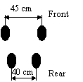  107 cm
12 | Caravelle 12 | 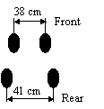  107 cm
13 | Canadair CL 44 | 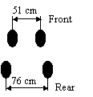  122 cm
24 | IL76T | 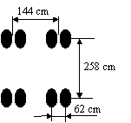
27 | Trident 1E | 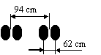  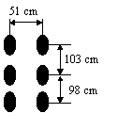
29 | TU154B

